

**Financial Statement Analysis Project**

Restaurant & Entertainment Chain Industry



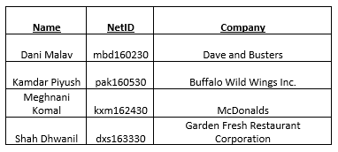 **Group 44:**

**INTRODUCTION**

Dave and Busters, Buffalo Wild Wings Inc., McDonalds and Garden Fresh Restaurant Corporation are among the top fast food and entertainment chains in the USA. They have a myriad number of services, ranging from arcade gaming and sports screenings to lip smacking food. All four companies have decent earnings and market shares in their respective fields of service.

**BUFFALO WILD WINGS INC.**

**Time Series Analysis**



Discussing the overall profitability for Buffalo Wild Wings Inc.: Earnings per share was $0.5372 in 2013, rising to $0.6353 in 2014, decreased to $0.5928 in 2015 substantially increased to $0.6435 in 2016. The positive and increasing earnings per share indicate investors will be willing to pay more for higher profits. At the same time, however, investors shouldn't ignore potential risks to Buffalo Wild Wings' business going forward. The profit margin has shown a fall of 0.0088 (15.5% approx.) through the years. The gross margin has been consistent through the years showing a gradual increase in sales as well as Cost of goods sold. The current and quick ratios both have shown a decrease (both are below 1) through the years which means the company has increasing liabilities and/or decreasing assets.

**Risk Factors**

Even if Buffalo Wild Wings continues to grow sales quickly, increasing operating costs could eat into its bottom line. Buffalo Wild Wings Inc. is on the verge of reaching saturation in the US, which in turn will slow down growth. And the recent shift in consumers' preferences toward healthier, faster options could be bad news for Buffalo Wild Wings. Consider a prime example in the remarkable rise of healthy-burrito maker Chipotle Mexican Grill, which grew revenue 28.6% year over year and has a sales growth of 17.3%.

**Business Opportunities and Threats**

Initiate and commit to a dividend at some point to make the stock more attractive once the US market is saturated with restaurants. The company should start the planned international expansion as soon as possible, witness the popularity of competitor Yum! Brands (NYSE: YUM) Kentucky Fried Chicken in China. Sports, especially soccer, has just as many rabid fans overseas as football and basketball here. Biggest threats to Buffalo are Continued input cost volatility, Fewer high-profile sporting events, Dilution of the concept through too many brand extensions.



**DAVE AND BUSTERS**

**Time Series Analysis**

Discussing the overall profitability for Dave and Busters Inc. earnings per share was a boom from 2014 to 2017 by an increase of 32%. This positive and increasing EPS indicates that the investors are willing to pay more for higher profits. The company is increasing on its own way; this can be validated by the increase in the profit margin by almost of 27.5% and the gross margin by 2.1% from 2014 to 2017. Due to this increase in the profit and gross margin they have increased in the liabilities from 2014 to 2016 which reduced the quick ratio by 66%.

**Risk Factors**

Since the ARCADE industry is very uncertain and old school it is going to be difficult to find a stable market to invest in and make sure that the return on investment is fruitful. Per the numbers, Dave and Busters is increasing which will attract more investors, the only risk would be the ROI. Well which business does not depend on the uncertainty of the market.

**Business Opportunities and Threats**

Strong opportunity to expand operations in Canada as they are already successful in United States Advertising and marketing can help boost the brand image globally specially in Canada. Utilize the uniqueness of being a restaurant and an entertainment hub. Threat from established competitors and new entrants. Rise in prices of raw materials can affect profitability. Unfavorable govt regulations can affect business

**GARDEN FRESH RESTAURANT CORPORATION**

**Time Series Analysis**

The profit margin for Garden Fresh Corp. in the first year of analysis was 0.0274 which was almost halved in the next three years of analysis, ending up at 0.01357. This indicates that Garden Fresh has declined its market share over the period of years. The gross margin has been almost consistent over the period of four years between 0.7483 and 0.7554. The current ratios increased strongly from 0.2504 in the initial year of analysis to 0.6963, which indicates that the company’s assets increased as compared to its liabilities. Similarly, the quick ratio for the firm has seen a gradual increase from 0.0858 to 0.4195, signifying growth in assets or decline of liabilities.

**Risk Factors**

Garden Fresh Corp operates in an industry which is very competitive and always changing with respect to the customers’ requirements and risk factors from time to time. The brand value also plays a vital role in the company’s profitability and overall earnings. The spending capacity of the customers, their economic stability and the general financial situation of the country also acts as a source of risk for the business. Due to low profit margins, the company might have to decrease expenses leading to a risk of shortfall of customers’ and incurring further losses.

**Business Opportunities and Threats**

Garden Fresh Corp. can generate business opportunities by looking to grow its business by merging with another restaurant chain. In doing so, it can venture into a completely new market with different menu options or it can delve further into the market it is already in. As the company’s operations are highly dependent on reviews and customer satisfaction, it becomes one of the threats in the food industry.

**McDONALDS**

**Time Series Analysis**

Discussing the overall profitability for McDonalds, earnings per share was $5.59 in 2013, substantially decreased to $4.85 in 2014, decreasing to $4.82 in 2015 & substantially increasing to $5.49 in 2016. The profit margin was 0.2959 in 2013 and reduced to 0.2618 in 2014 followed by 0.2746 in 2015 & increased to 0.3064 in 2016. The gross margin was 0.9422 in 2013, in 2014 and 2015 it was almost similar as 0.839 & 0.841 respectively whereas in 2016 it was 0.8510. In terms of current ratios, McDonald’s current assets was more than its current liabilities in all the four years with current ratio 1.59, 1.52, 3.26 & 1.39 in 2013, 2014, 2015 & 2016 respectively. Its quick ratio has been varying for the four years.

**Risk Factors**

At the end of 2013, McDonalds had 40% of debts denominated in foreign currencies. Many studies conducted bought criticism to McDonald’s in terms of food quality. By changing to move from being a junk food restaurant to having a healthier menu posed a huge risk concerning to the existing customer’s set perception. There have even been labor strikes & protests against McDonalds which pose as future risk as well.

**Business Opportunities and Threats**

At the end of 2014, McDonald’s had 36,528 restaurants in 119 countries and expects to have more such franchises around the world. It even receives royalty from its franchisee which allows the company to significantly increase the level of cash flow. It has various threats such as its biggest competitors are Burger King & Wendy’s. To add to the competitors even the restaurant menu poses a threat as there are constantly rising number of health-conscious consumers which might hurt the business in long run.

**CROSS SECTIONAL ANALYSIS**

**Overall Profitability**

Analyzing the gross margin over the years 2012 to 2015 (Fig 4.1 & Fig 4.2), we can conclude that McDonalds makes profit in all the years followed by Garden Fresh Restaurants, Dave and Busters and Buffalo Wild Wings.

**Components of Profitability**

Comparing the profit margins, returns on equity and earnings per share of these companies helps us to find out profitability and predict which company can do decent in the future. From Fig 1.1 and 1.2 we can say that McDonalds is doing quite good followed by Dave and Busters. Buffalo Wild Wings and Garden Fresh must make some changes to perform well.

**Risk Ratios**

The Current and Quick Ratios emphasize on assets to liabilities components of the companies. We can see from Fig 2.1 and 3.1, Mc Donald has pretty balanced assets to liabilities ratio as well as their cash + market securities value is dependable to invest. Buffalo Wild Wings and Dave and Busters shows more fluctuations, while Garden Fresh Restaurant is not a good company to invest upon.

**Suggestions**

Looking at the Earnings per share, Debt-Assets Ratio, Profit Margin and Return on Equity of the firms, McDonalds is likely to be more successful in future.

|  |  |  |  |  |
| --- | --- | --- | --- | --- |
| **Company** | **Year 1** | **Year 2** | **Year 3** | **Year 4** |
| **Dave and Busters** | 2014 | 2015 | 2016 | 2017 |
| **Buffalo Wild Wings Inc.** | 2013 | 2014 | 2015 | 2016 |
| **McDonalds’** | 2013 | 2014 | 2015 | 2016 |
| **Garden Fresh Restaurant Corp.** | 2000 | 2001 | 2002 | 2003 |

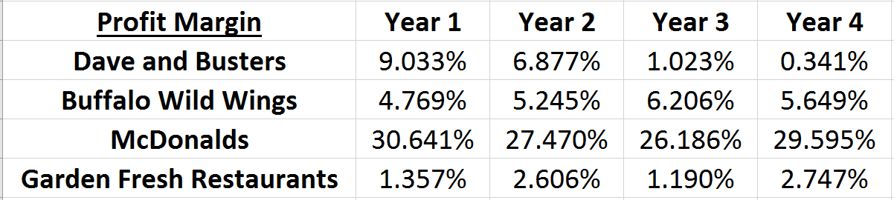**PROFIT MARGIN ANALYSIS**

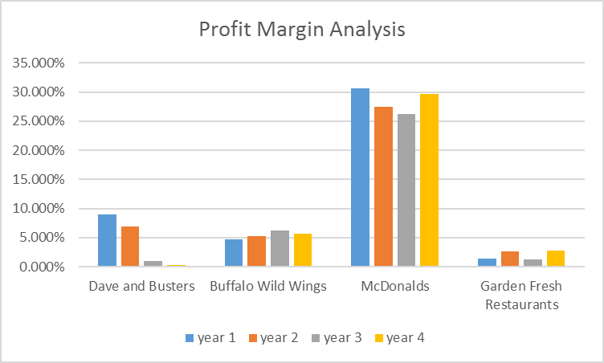

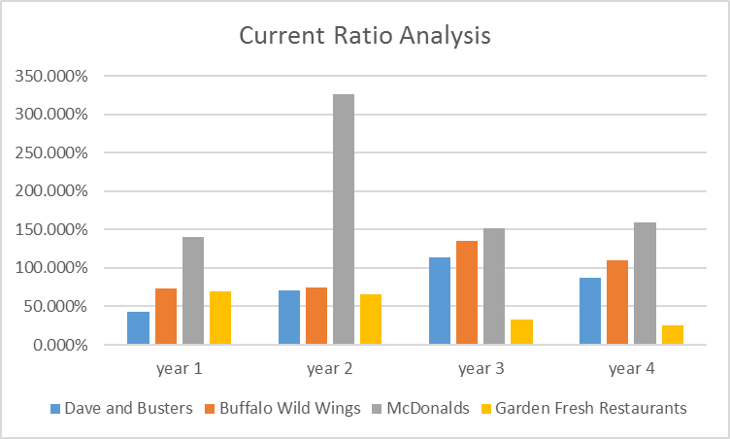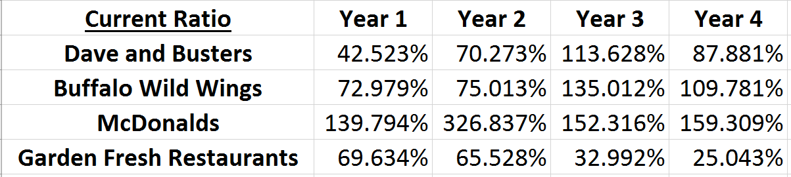**CURRENT RATIO ANALYSIS**

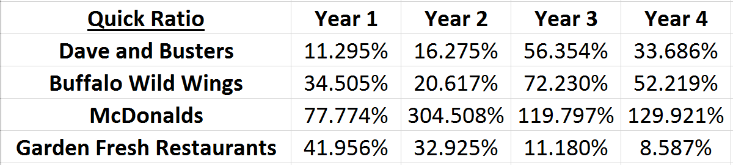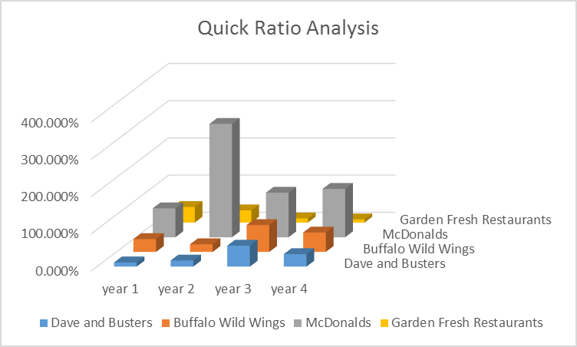**QUICK RATIO ANALYSIS**

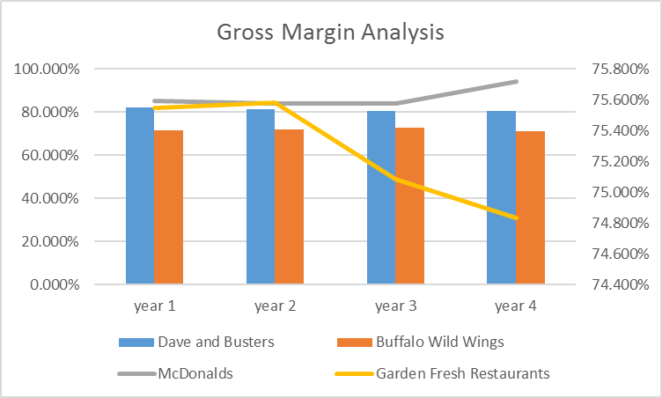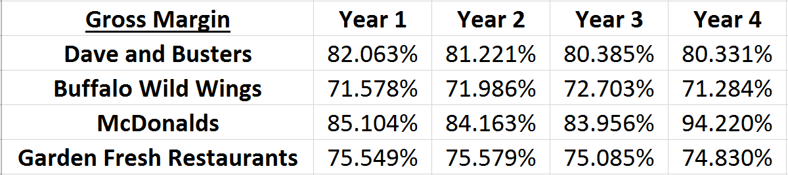**GROSS MARGIN ANALYSIS**